**Keysight Shopping Cart**

* How long did you spend on your solution?

I have spent 2-3 days developing it. First, I began to develop it thinking of a more complex website, with additional functions that were not necessary for this solution, as you can see in this image.

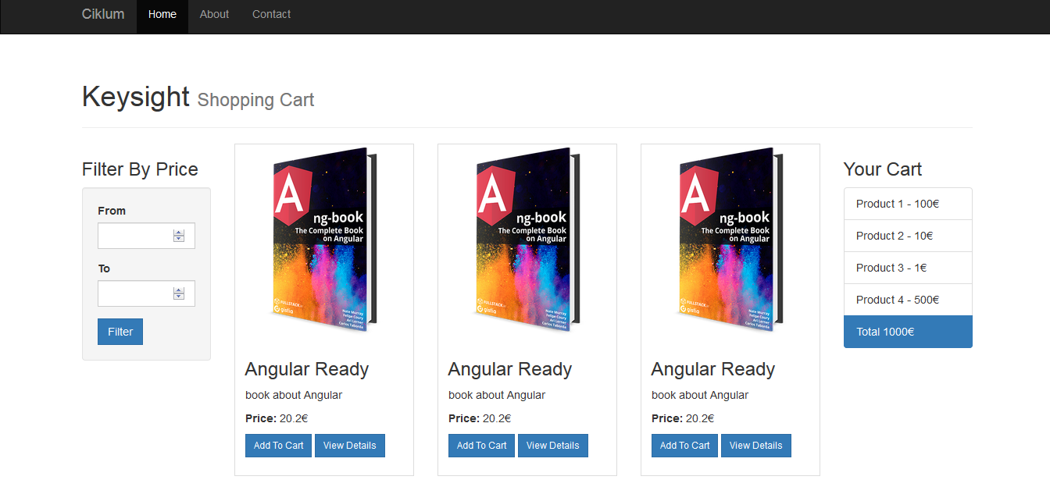

I have even been making a .NET solution with ADO.NET and Entity Framework, creating a SQL Server database thinking of sending both solutions, thus increasing the chances of being selected for the job offer, but it was very difficult for me to have enough time these days, so I ruled it out:



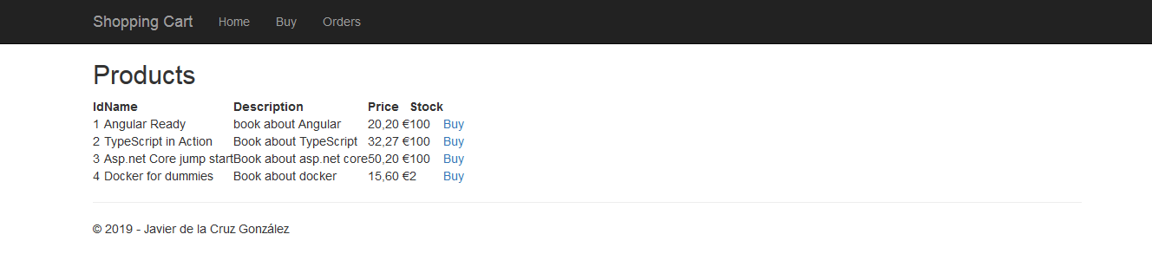

After that, I concentrated on developing the final solution attached:

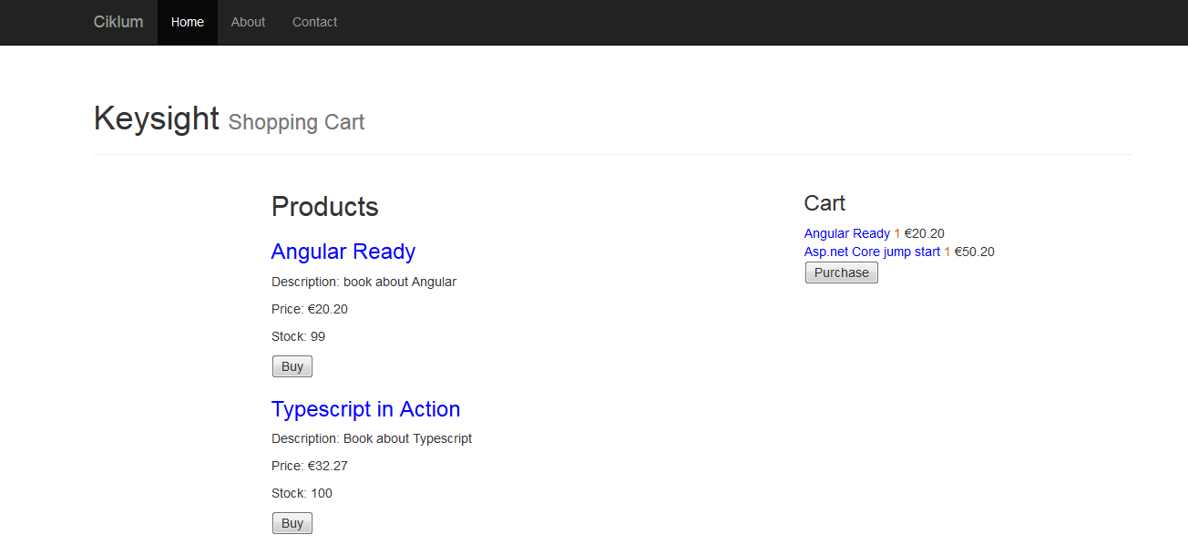

* How do you compile and run your solution?

It has been developed using Angular and Visual Code. I have compiled and executed the solution using the directive:

*ng build --prod*

*ng serve*

* What assumptions did you make when implementing your solution?

I have assumed that the language of the application must be English. I did not develop any login or order details section, nor have I spent time implementing CSS styles or creating an elaborate visual aspect because it was not required in the documentation.

* Why did you pick the design that you did?

As I say, I have not spent too much time choosing a design because it was not a requirement to develop the solution. I choose this one because there are few products to display and you can visualize them all in a simple, elegant and professional way.

### User Story 4

#### Tittle

As a owner of the site I want to scale our the application so it can work smoothly even in intense web traffic conditions (Black Friday).

We can take into account all these points so that our application works smoothly in conditions of intense web traffic:

* Scale our application into a progressive web application (PWA).
* Reduce the CSS and JS files.
* Maximize the Front End part without touching the server part.
* If the hosting service is not as good as the one we need, we should change it to a faster one.
* Reduce the installation of plugins.
* Optimize multimedia content.
* Reduce HTTP requests.
* Optimize the code, not using a compressed one.
* Compress the images.
* Use CSS Sprites.
* Optimize the Cache memory.
* Reduce Flash elements.